wUse Of Java 8 Features

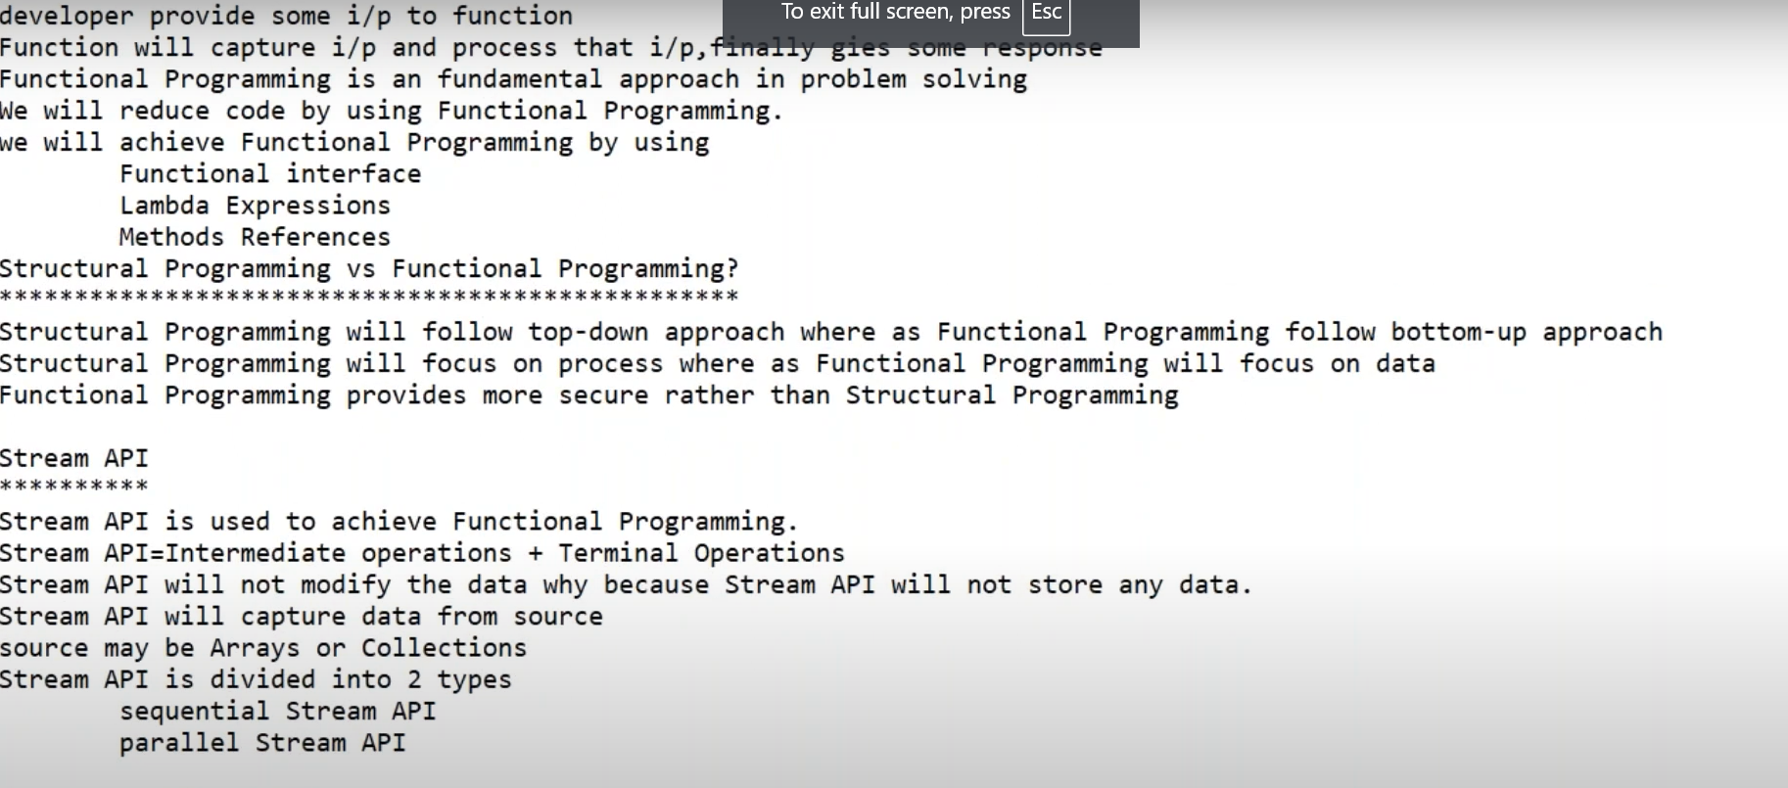
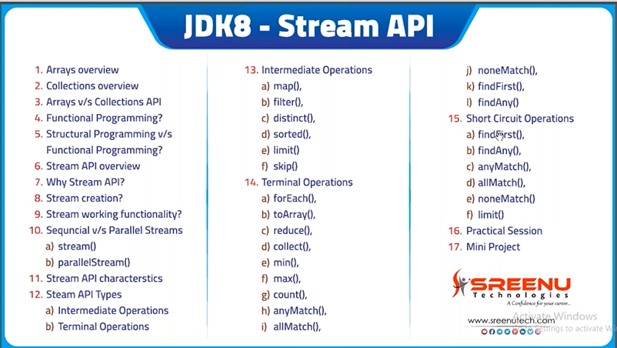
To Count or find length
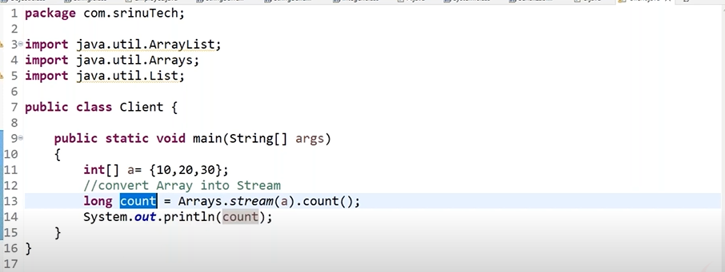
Iterate in Stream
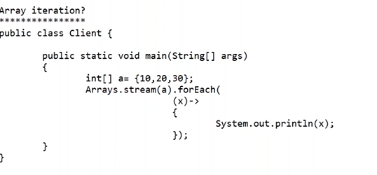

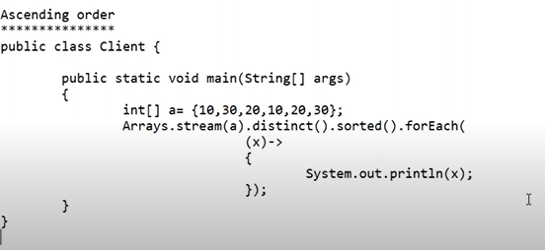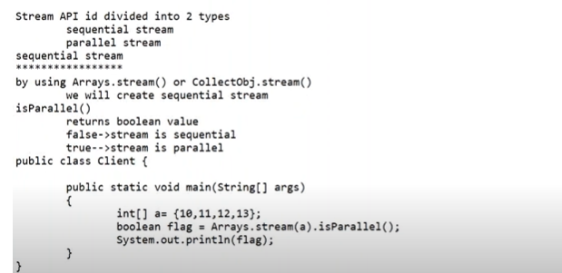
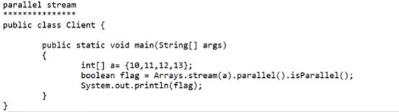
StreamAPI is combination Of intermediate Operation and terminal Operators
All Intermediate operation Generates new Streams Only.
In Stream intermediate operations can be use mutltiple times but terminal perators will use only one time
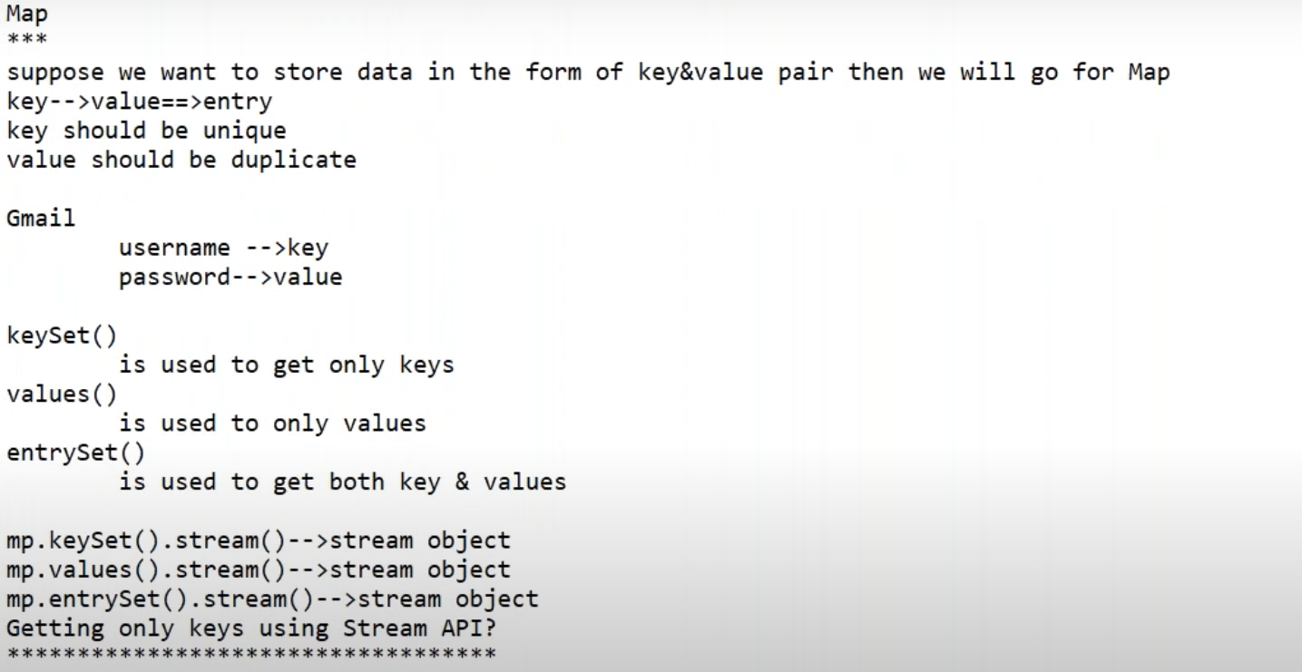
// find distinct elemtnsfrom array
int newArr[] = Arrays.stream(arr).distinct().toArray();
// Convert int[] to Integer[] for working with Set
Integer[] arrBoxed = Arrays.stream(arr).boxed().toArray(Integer[]::new); // constructor reference
// Use HashSet to remove duplicates
Set<Integer> removeDuplicate = new HashSet<>(Arrays.asList(arrBoxed));

// Convert Set back to array or print
Integer[] uniqueArr = removeDuplicate.toArray(new Integer[0]);
//remove duplicates from a list using Java Streams
List<String> filteredList =lst.stream().distinct().collect(Collectors.toList());
// print duplicates
filteredList.forEach(x-> System.out.println(x));
filteredList.forEach(System.out::println); // Method Reference
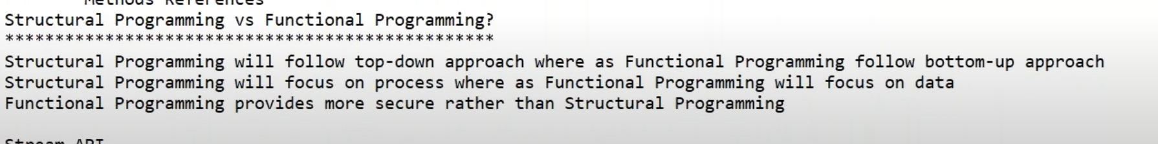
FlatMAp is used to convert two dimensional array to single dimensional Array

